



***DON’T JUST THINK***

***MAKE IT HAPPEN!***

**BABJI NEELAM**

**FOUNDER & CEO**

**PROJECT TITLE**

**CONTENERIZATION OF DESKTOP APPLICATION USING DEVOPS**

Under the esteemed supervision of

Mr. Bobby

Mr. Surya Ashok

TEAM NAME: **SUGS_S**

M SANDHYA : 20P31A0537

N SURYAKALA : 20P31A0538

P GOWRI ALEKYA : 20P31A0546

J SANJAY : 20P31A0589

K UMA PARVATHI DEVI : 20P31A0592

# PROJECT OVERVIEW

# In today's fast-paced world, it is crucial for educational institutions to keep track of their students' attendance. With the advancements in technology, it has become easier to maintain attendance records digitally. However, sending attendance notifications to students can still be a cumbersome task. This is where our desktop application using Tkinter comes in handy. The application can be used to send attendance notifications to students when they tap their attendance with class, date and time. Additionally, the app is deployed in docker to ensure easy installation and maintenance.

# Our desktop application has been developed using the Tkinter library in Python. The app will allow trainers to take attendance using an RFID reader. When a student taps their RFID card, the attendance information will be stored in a local system in an excel sheet. The excel sheets will also contain the email addresses of students. The application will then send an email to the respective student notifying them of their attendance status in their training sessions.

# One important feature of this application is the ability to add or remove events instantly. This feature allows users to easily manage their schedules and stay organized. With the ability to add events, users can quickly create new attendance sheets in the application and can take the attendance of the students attending the event. On the other hand, the ability to remove events allows users to free up the data that is not necessary in their application.

# To ensure easy deployment and maintenance, the app has been deployed in docker. Docker is a containerization platform that enables developers to package their applications along with all their dependencies into a single container. This container can be deployed on any platform without worrying about compatibility issues.

# 6 Benefits of a Good Business Emailing System

# PROBLEM STATEMENT

Students attend classes and make sure to record their attendance on the designated portal. However, despite this effort, they still face the inconvenience of having to manually log into the portal just to check the status of their attendance. This is because the portal does not provide automatic updates or notifications regarding attendance status.

In addition, there are instances where technical difficulties occur, and the attendance record is recorded as absent even though the student attended the class. In such cases, students are left in the dark and cannot determine their attendance status unless they manually check their account on the portal.

Furthermore, data on attending students is manually separated and provided to the appropriate colleges. This manual process can be inefficient and prone to errors. In some cases, attendance may be recorded as present in the training database but marked as absent at the college. This poses a problem for students because they have no other way to justify their presence other than to physically show up and obtain a formal document from the training institution stating that they were present.

While the data from regular training sessions is kept in the database, there seems to be a lack of organization when it comes to recording data from new programmes or events. This could lead to inconsistencies and confusion when it comes to tracking attendance records for these events.

Overall, to make the process easy and efficient, we made improvements and upgrades to the system to provide automatic updates and notifications, reduce the manual process, and ensure accurate tracking of attendance records.

**SCOPE OF THE PROJECT**

The project will focus on the development of an attendance tracking system for students at a college. The system will automate the process of tracking and reporting attendance, and will include a user interface for trainers to monitor attendance and view attendance data. The project will not include any other features or functionalities beyond attendance tracking.

The primary objective of the project is to eliminate the manual attendance system by automating the process of tracking and reporting attendance. The system should be able to accurately record which students are present for each session and separate the attendance data for those students who are present from those who are absent. The attendance data should then be forwarded to the appropriate college emails.

The deliverables for the project will include a fully functional attendance tracking system, including the user interface for trainers to monitor attendance and view attendance data. The system should be able to scale to accommodate large numbers of students and sessions, and it should be secure to protect student data. Additionally, the project may involve documentation, training materials, and support for the adoption and integration of the system into existing processes at the college or university.

The project will have budget, time, and resource constraints. The budget for the project will be limited, and the project will need to be completed within a specific timeframe. The development team will have limited resources, and will need to work efficiently to ensure that the project is completed on time and within budget. Additionally, the system will need to comply with any regulatory or legal requirements related to the collection and storage of student data.

**PURPOSE OF THE PROJECT**

This application aims to revolutionize the attendance tracking process by replacing the traditional manual system with automation. The program automatically segregates and forwards attendance data of present students to their respective college emails, simplifying the verification process for students and easing attendance management for institutes. Moreover, trainers can conveniently monitor the attendance of each trainee with ease.

The benefits of this application extend beyond simplifying attendance tracking. With automation, organizations can respond more rapidly to changing requirements, as checking attendance status becomes quicker and more manageable. This increased flexibility allows institutions to adapt to new challenges with ease.

Automation also ensures consistency and reliability of data, reducing the risk of errors and increasing overall system reliability. This not only simplifies the attendance tracking process but also minimizes errors that could lead to discrepancies in attendance records.

In addition to improving reliability, this application reduces the operational overhead associated with managing attendance manually. By automating attendance tracking, organizations can significantly reduce the amount of manual effort required, freeing up time and resources for other critical tasks.

In conclusion, this application is a game-changer for attendance tracking, offering a wide range of benefits that improve efficiency, reliability, and consistency while reducing the burden of managing attendance manually.

**TOOLS USED**

**Python Programming:**

To create the application, we used python programming and in that, we have used many libraries and modules.

The libraries and modules we have used are:

* Tkinter
* SMTP
* Emails
* Pandas
* Openpyxl

**Tkinter:**

We have used Tkinter module for the creation of GUI (Graphical User Interface). Tkinter is a GUI (Graphical User Interface) toolkit that is included with Python. It provides a set of tools for creating graphical interfaces, such as windows, buttons, labels, and more. Tkinter is easy to use and is a good choice for developing simple GUI applications.

**SMTP:**

We have used SMTP (Simple Mail Transfer Protocol) module for sending Email Alerts. The SMTP (Simple Mail Transfer Protocol) library in Python allows you to send emails from your Python code. We can use it to send email notifications or alerts when certain events occur in your application. The SMTP library provides a simple interface for sending email messages.

**Emails:**

We have used the email module for email-related functions. The email module in Python is a built-in module that provides a set of classes and functions for creating, parsing, and sending email messages. It supports both plain text and HTML formatted messages, as well as attachments and other advanced features.

**Pandas:**

The pandas module in Python is a popular library for data manipulation and analysis. It provides data structures and functions for handling and manipulating data in various formats, including CSV, Excel, SQL databases, and more. The pandas module is built on top of the NumPy module, which provides support for numerical computations.

**Openpyxl:**

Openpyxl is a Python library for working with Microsoft Excel files, specifically the Excel Open XML spreadsheet file format (XLSX). It allows us to read, write, and modify Excel files using Python code.

Here are some of the main features and capabilities of the openpyxl module:

**Reading Excel Files**: We can use openpyxl to read data from existing Excel files. We can load an existing Excel file into a workbook object and access individual worksheets and cells.

**Writing Excel Files**: We can use openpyxl to create new Excel files or modify existing ones. We can create new workbooks, worksheets, and cells, and populate them with data.

**Manipulating Excel Data**: openpyxl provides a wide range of functions for manipulating Excel data, such as formatting cells, merging cells, applying borders, and more. We can also apply formulas and functions to cells, and add charts and images to worksheets.

**Handling Large Excel Files**: openpyxl is designed to handle large Excel files efficiently. It uses a streaming approach to read and write Excel files, which means that it only loads the data that is needed, rather than loading the entire file into memory.

**Docker:**

We have used docker to deploy our application. Docker is a platform for containerizing applications. It allows us to package our application and all its dependencies into a container, which can be deployed to any environment that supports Docker. Docker provides a lightweight, portable, and scalable way to deploy our applications. It also makes it easy to manage your application's dependencies and configurations

**Linux:**

We have used linux to deploy our application. We have installed the docker in the linux evironment. We have build a docker image and written the docker file. We have copied files to the linux and run the application.

**PROOF OF CONCEPT**

**Python text editor**

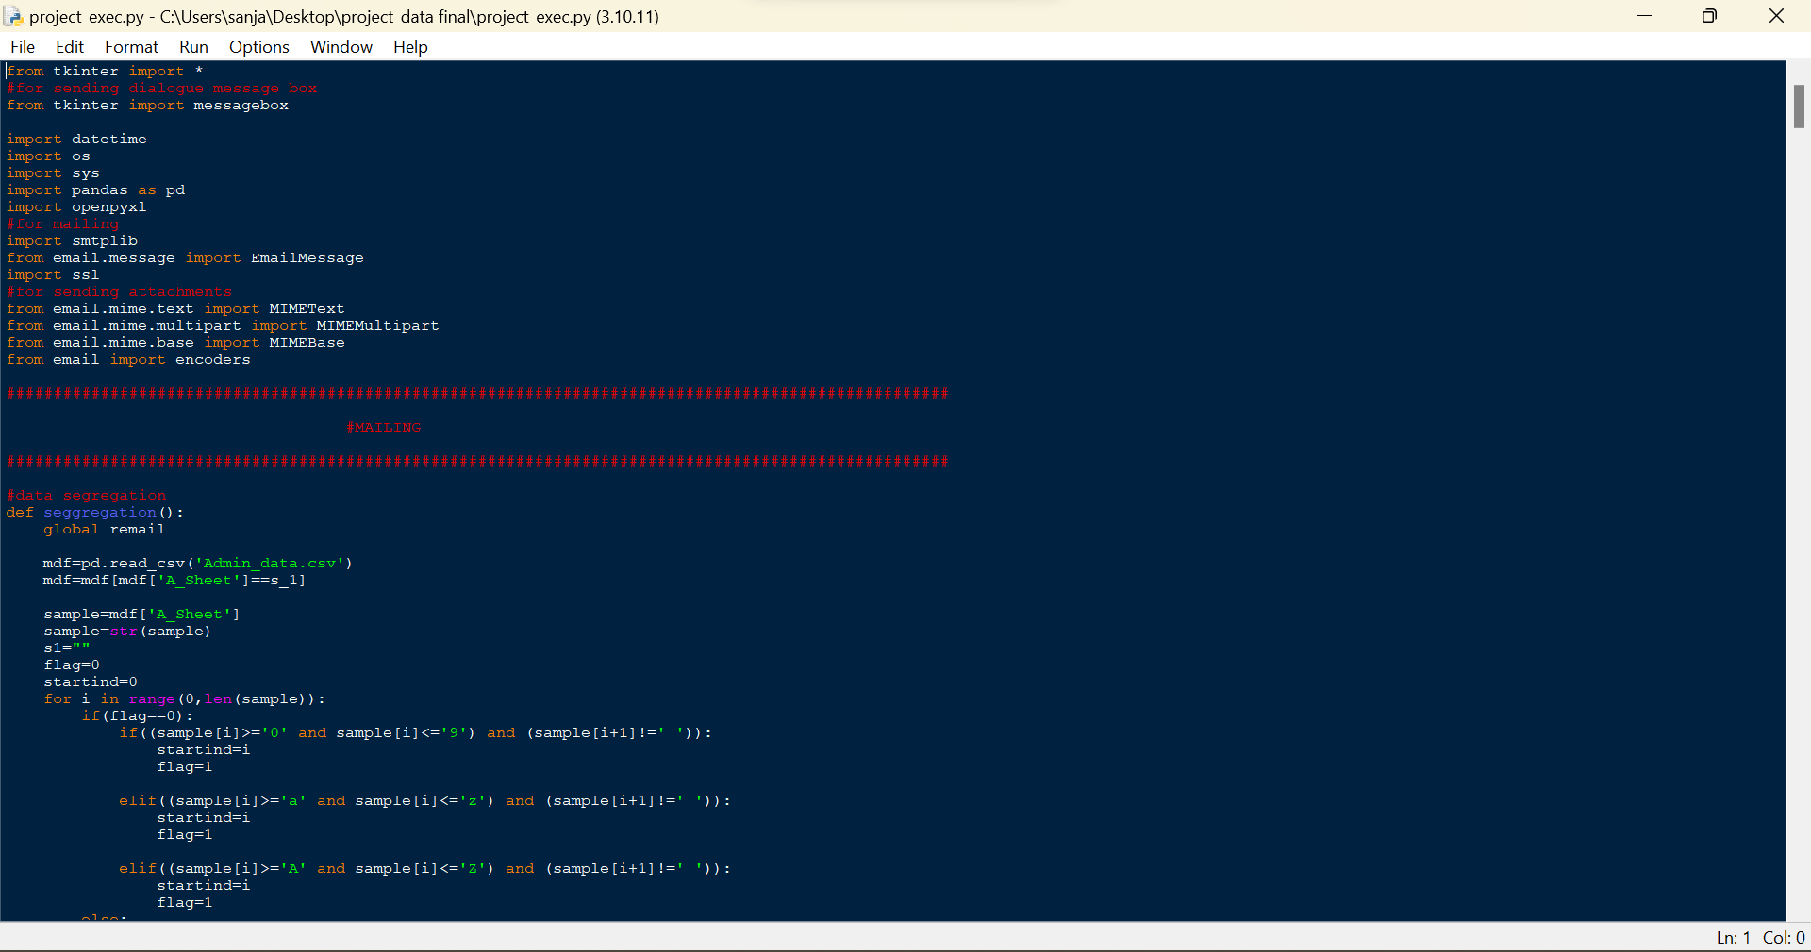

**Creating a Dockerfile**

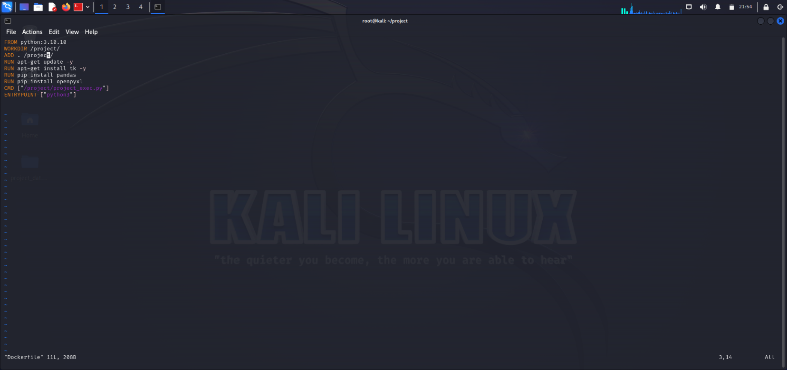

**Building a docker image**

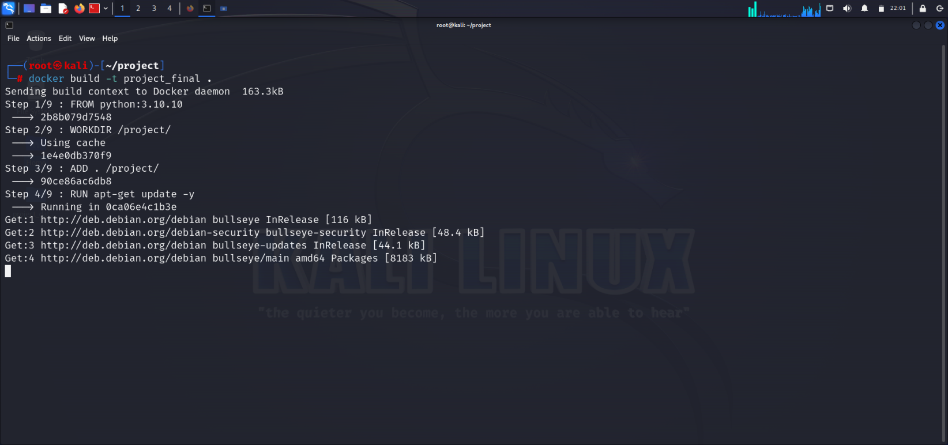

**Docker run command**

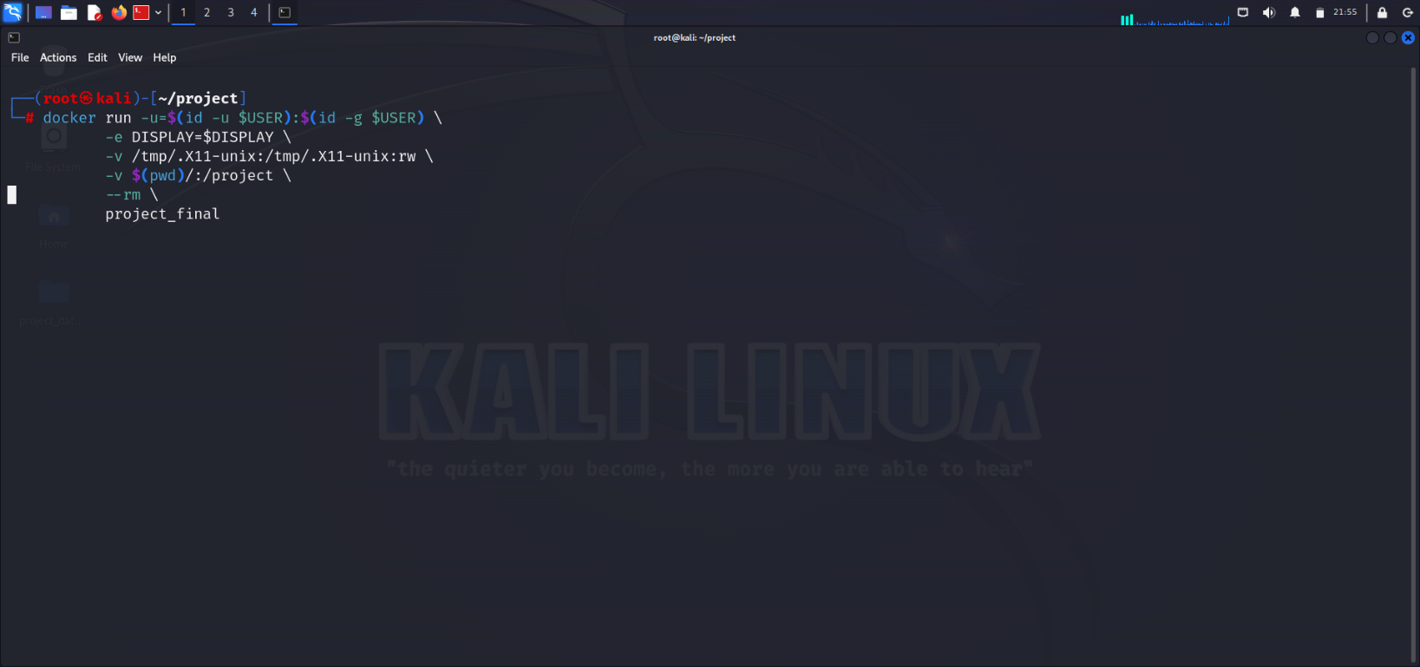

**Application homepage**

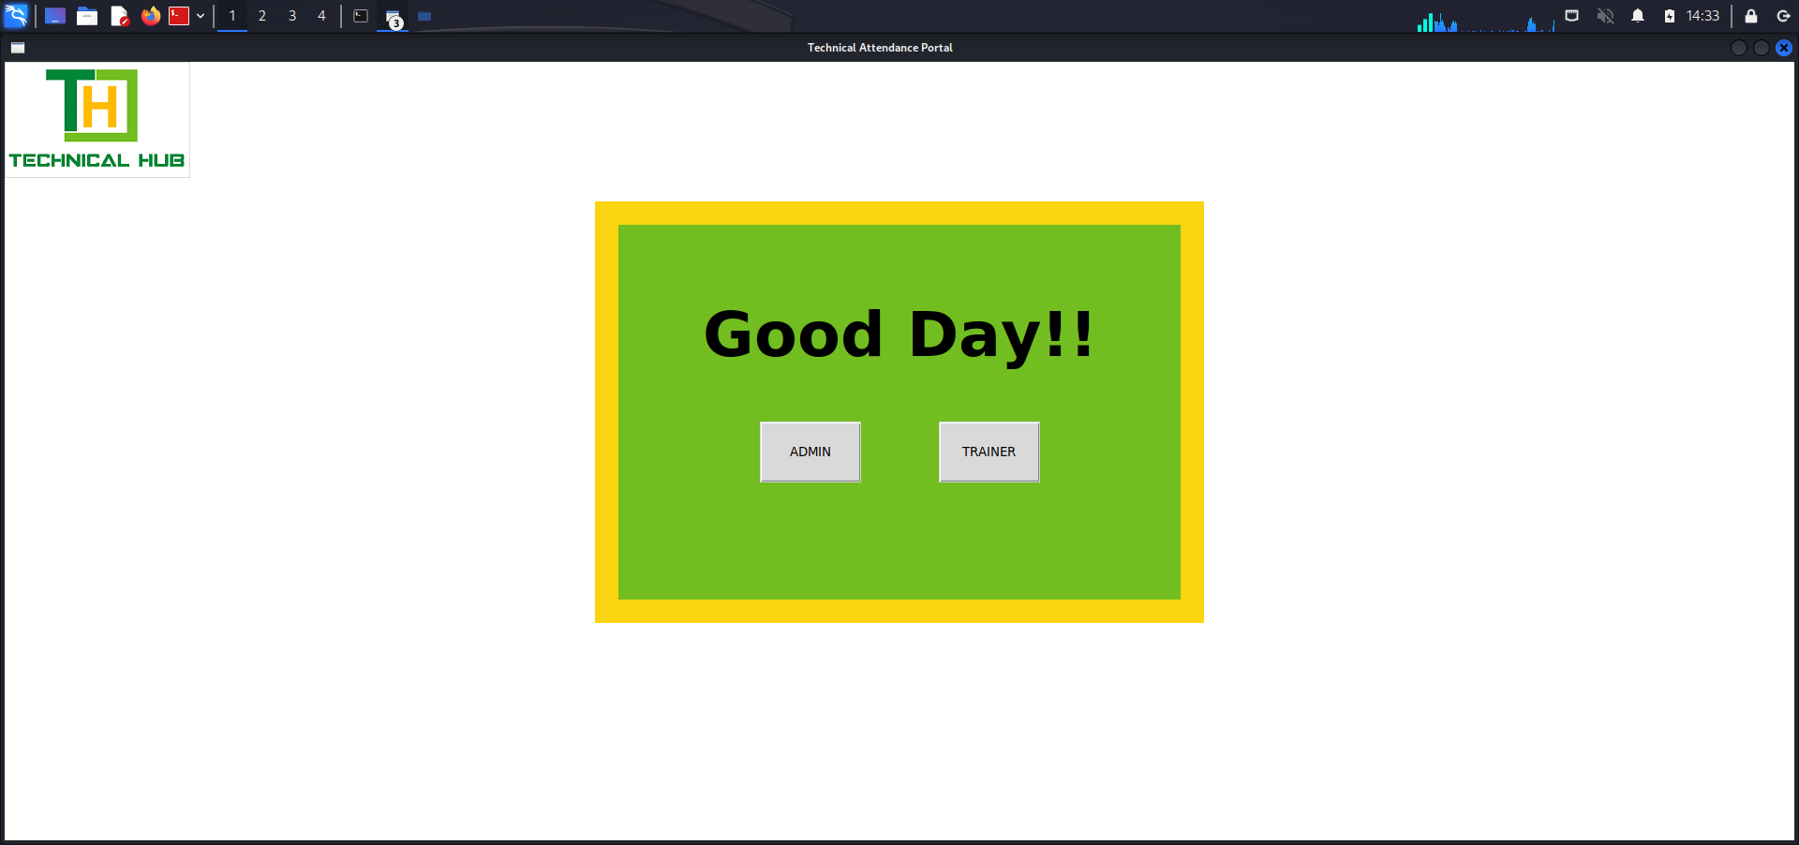

**Admin login page**

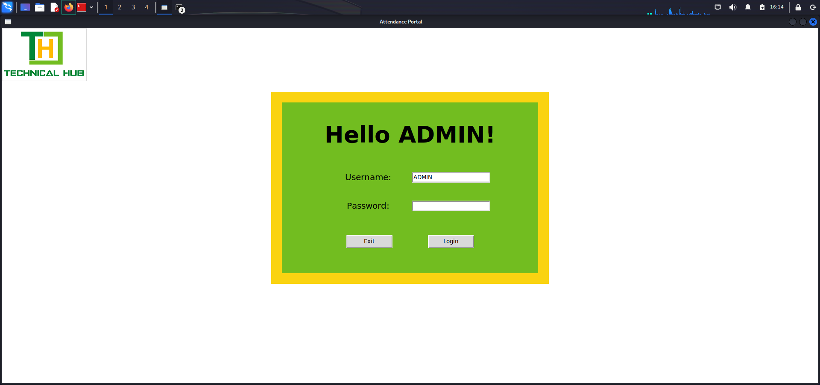

**Admin Properties page**

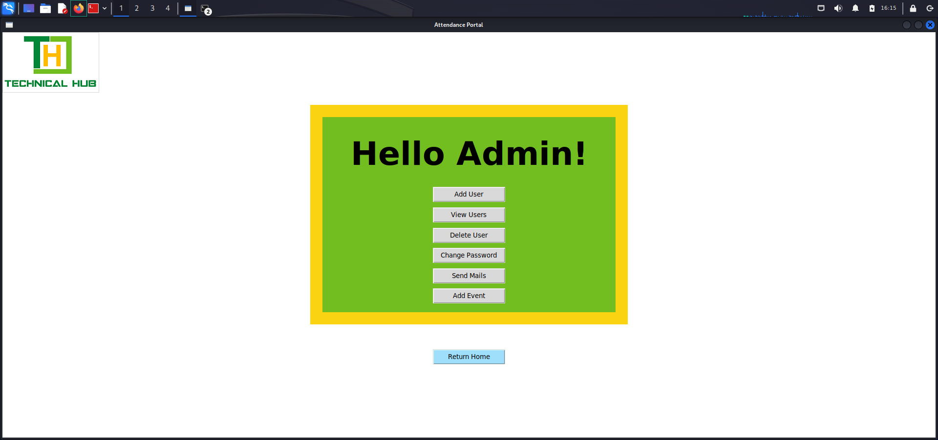

**Trainer login page**

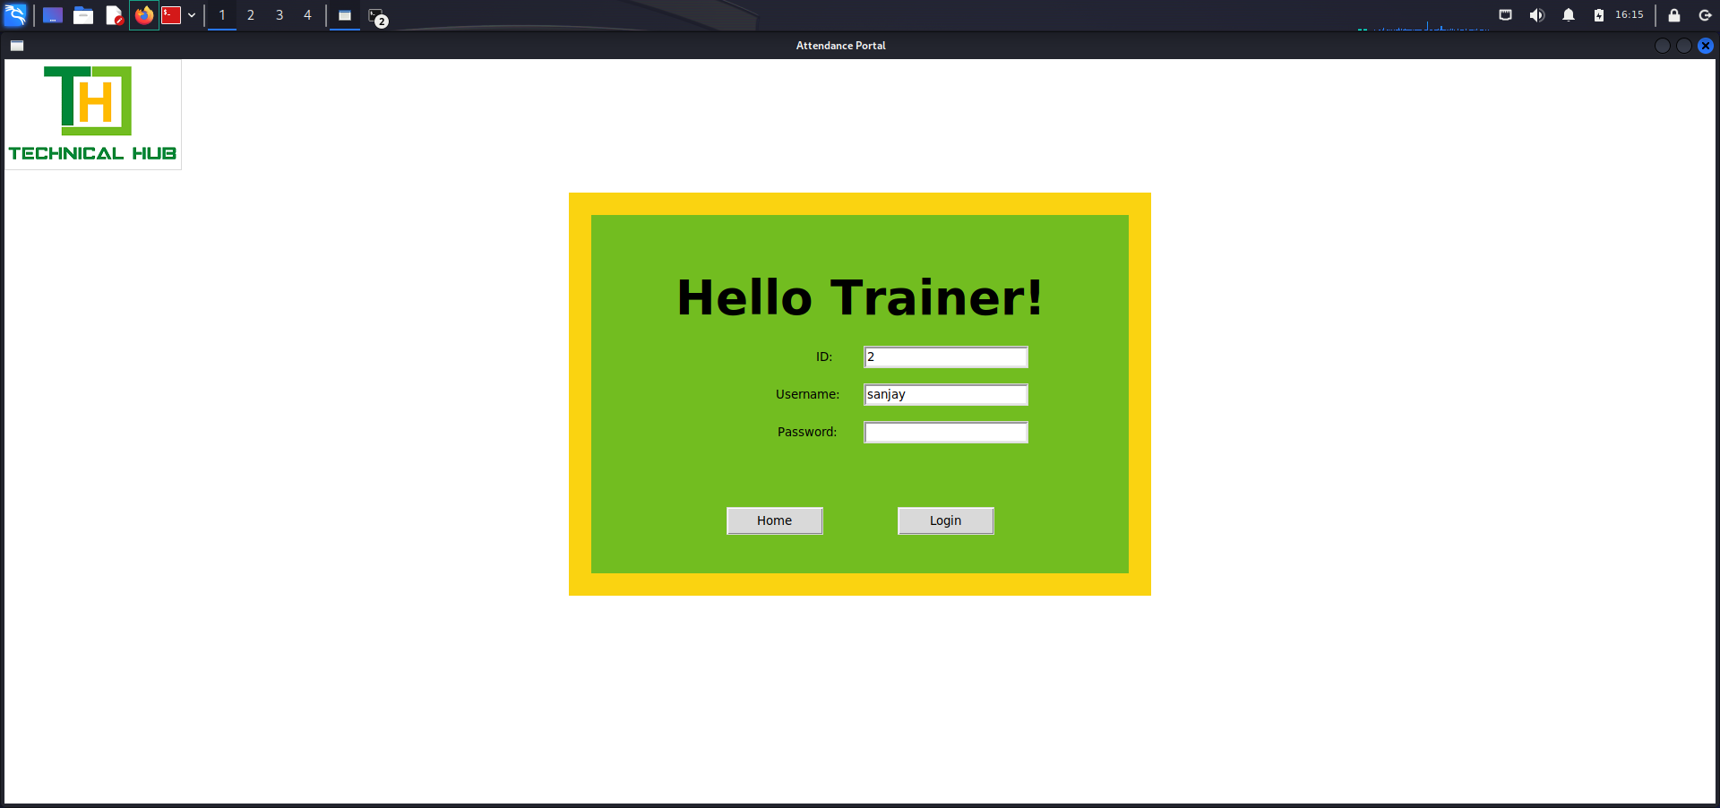

**Trainer properties page**

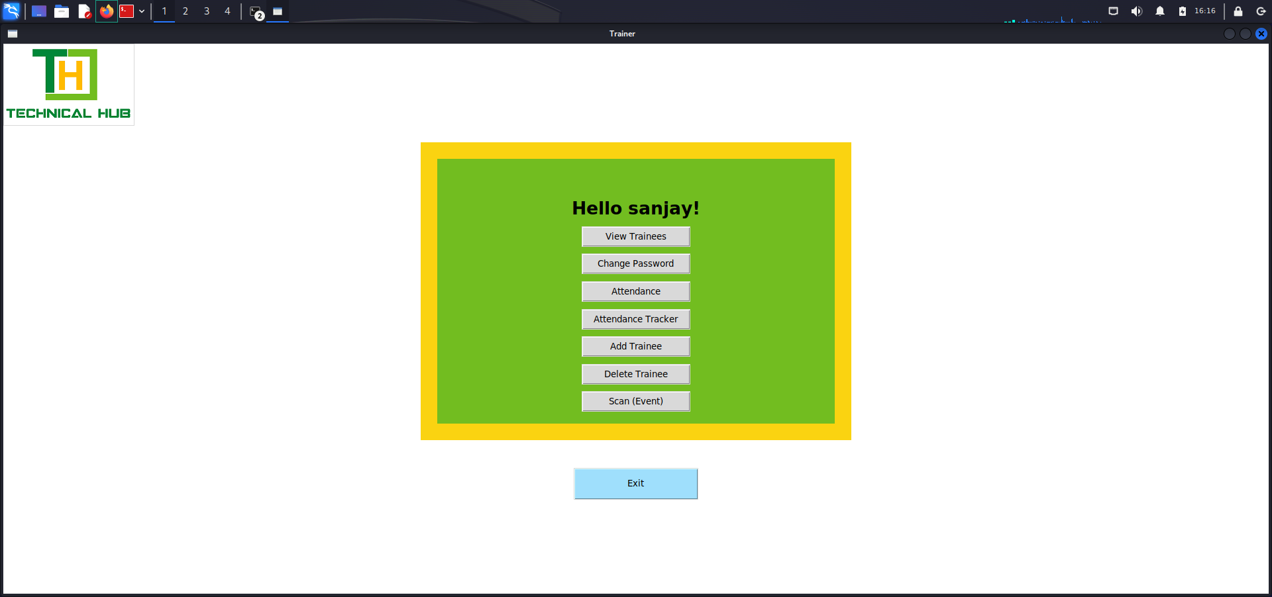

**Attendance scanning tab**

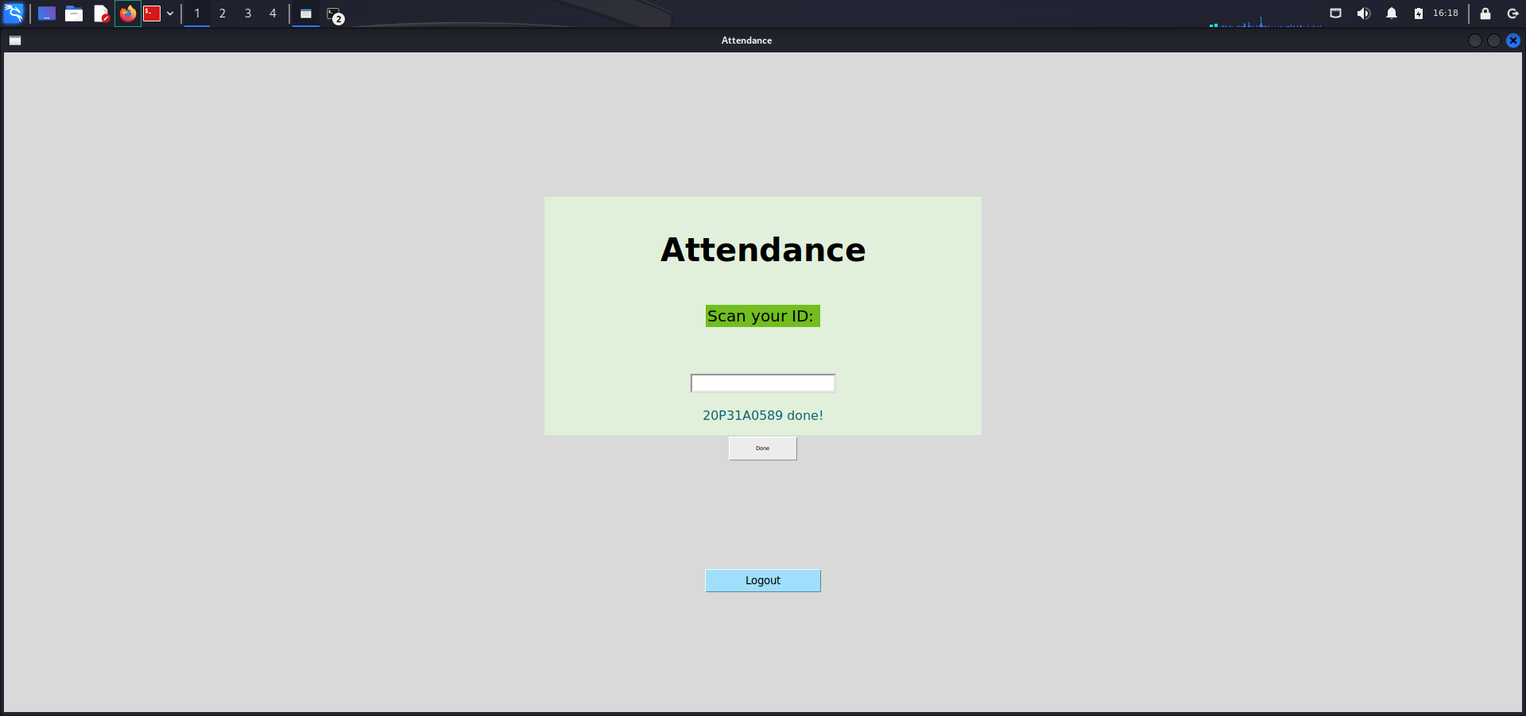

**REPOSITORY DETAILS:**

* [Python code](https://github.com/sanjay-jupakula/Project_space_Histily_Alert/blob/main/project_exec.py)
* [Dockerfile](https://github.com/sanjay-jupakula/Project_space_Histily_Alert/blob/main/Dockerfile)
* [Docker run command](https://github.com/sanjay-jupakula/Project_space_Histily_Alert/blob/main/Docker%20run%20command)
* [Sample users data](https://github.com/sanjay-jupakula/Project_space_Histily_Alert/blob/main/Admin_data.csv)

**OUTCOME**

This is a email notification which is automatically generated and sent without using any manual assistance.

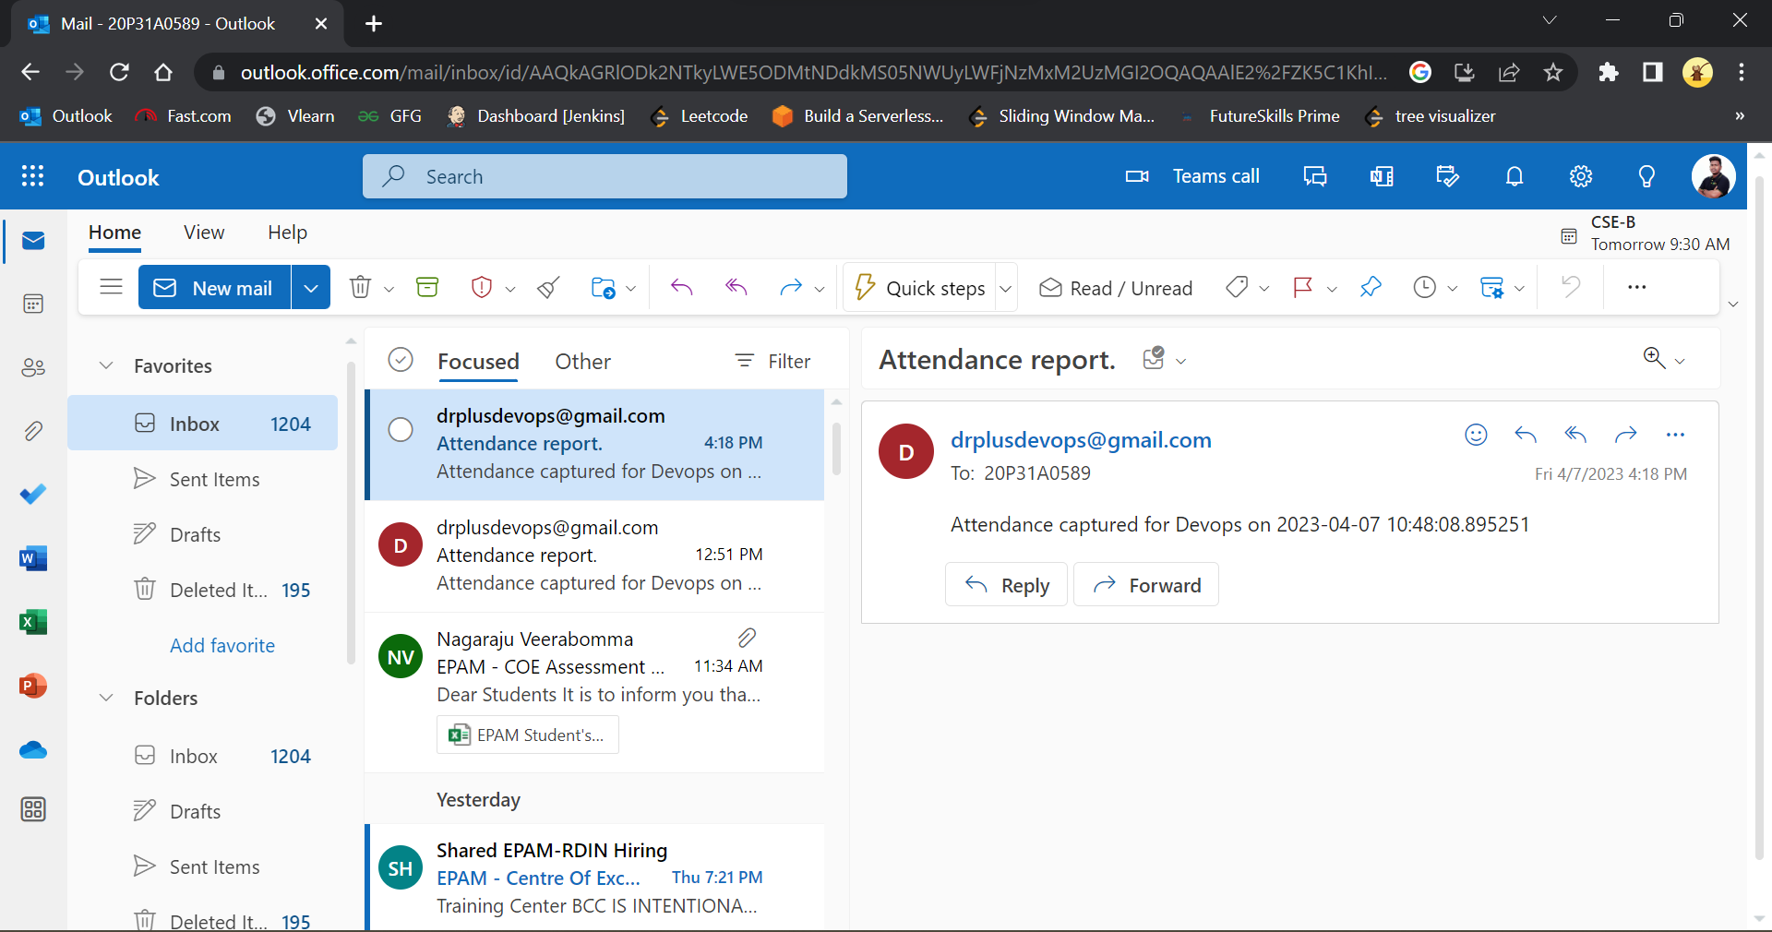

**CONCLUSION**

In conclusion, the desktop application developed is an innovative tool that not only sends email notifications immediately after attendance is tapped but also automatically segregates the data for respective colleges and sends it to their respective college emails.

This feature of the application is particularly useful for educational institutions that have multiple colleges or departments, as it streamlines attendance tracking and reporting. The application ensures that attendance data is accurately sorted and quickly delivered to the appropriate colleges, reducing the risk of errors and delays.

The email notifications sent by the application are also useful for keeping college staff and faculty informed about attendance updates in real-time. This feature can help to improve communication and collaboration within the institution, ultimately contributing to better student outcomes.

Overall, the desktop application provides an effective solution for managing attendance in educational institutions and improving communication among staff and faculty. The automatic segregation of data and email notifications make attendance tracking more efficient and accurate, ultimately benefiting the institution as a whole.

**THANK YOU**